

|  |  |  |  |  |  |  |  |  |
| --- | --- | --- | --- | --- | --- | --- | --- | --- |
|  | | | | | | | | |
|  | | Lab 4 | Penetration Testing a pfSense Firewall | | | | |  | |
|  |  | | | | | | |  |
|  | | | |  |  | | | |
|  | | | | Cesar Munguia |  | | | |
|  | | | | 10/16/2023—IS-3423-003—Darniet Jennings |  | | | |
|  | | |  | | |  | | |



|  |  |  |  |  |  |  |  |  |
| --- | --- | --- | --- | --- | --- | --- | --- | --- |
|  |  | | |  |  | | |  |
|  | Learning Objectives | | | | | | |  |
|  |  | | |  |  | | |  |
|  |  | |  | | |  | |  |
|  |  |  | Upon completing this lab, you will be able to:   1. Describe the steps of a penetration test. 2. Perform a penetration test against a network protected by pfSense firewall. 3. Discuss measures that can be taken to harden a target against attacks while balancing system access and usability needs. 4. Describe the difference between white-box, grey-box, and black-box penetration testing. | | |  |  |  |
|  | | | | |
|  |  |  |  |
|  |  |

# Section 1: Hands-On Demonstration

### Part 1: Examine a pfSense Firewall Configuration

1. On the vWorkstation taskbar, I **clicked** the **Chrome icon** to open a new browser window.
2. In the browser navigation bar, I **typed 172.30.0.1** and **pressed Enter** to navigate to the pfSense Web GUI. When prompted with a warning, I **clicked Advanced**, then **clicked Proceed to 172.30.0.1 (unsafe)** to continue.
3. At the pfSense log-in screen, I **typed** the following credentials [Username: admin; Password: pfsense] and **clicked OK** to log into the application.
4. From the pfSense menu bar, I **clicked** **Firewall**and **selected Virtual IPs** to open the Firewall / Virtual IPs page.
5. On the Virtual IPs page, I **reviewed**the **Virtual IP Address list**. [The Virtual IP Address list currently contains one Virtual IP address, 202.20.1.3, which is associated with the WAN interface and used to access the internal 172.30.0.15 server over public networks using 1:1 Network Address Translation (NAT).]
6. From the pfSense menu bar, I **clicked** **Firewall**and **selected NAT**to open the Firewall / NAT / Port Forward page.
7. On the NAT / Port Forward page, I **clicked** the **1:1 tab** to open the NAT / 1:1 page.
8. On the Firewall / NAT / 1:1 page, I **reviewed** the **NAT rules list**. [The NAT rules list currently contains one rule, which translates the external IP address 202.20.1.3 to the internal IP address 172.30.0.15. This means that all traffic sent to the 10.20.1.3 address will be forwarded to the 172.30.0.15 server, which is protected by the firewall rules on the WAN interface.]
9. From the pfSense menu bar, I **clicked** **Firewall**and **selected Rules** to open the Firewall / Rules / WAN page.
10. On the Firewall / Rules / WAN page, I **clicked**the **LAN link** to review the outbound rules, which identified the types of traffic from the private (internal) network at 172.30.0.0/24 that will be allowed to pass through the firewall to the public (external) network (202.20.1.0/24).

* **File Transfer Protocol (FTP):** Enables users to send files back and forth
* **Domain Name Service (DNS):** Enables users to type URLs, instead of requiring them to know specific IP addresses of any Web sites they wish to visit
* **Email Send:** Enables a user to send e-mail to any server using the Simple Mail Transfer Protocol (SMTP)
* **Email Receive**: Enables Post Office Protocol, version 3 (POP3) so that users can retrieve e-mail from any server
* **Remote Management:** Enables users to remotely manage a Linux/Unix server by a Secure Shell (SSH) command-line interface
* **Internet Browsing:** Enables Internet browsing using the HTTP protocol
* **Secure Internet Browsing:** Enables Internet browsing using the HTTPS protocol
* **Ping**: Enables Internet Control Message Protocol (ICMP) messages, such as PING

1. In the pfSense window, I **clicked** the **WAN tab** to review the inbound rules, which identified the types of traffic from the public (external) network (202.20.1.0/24) that will be allowed to pass through the firewall to the private (internal) network (172.30.0.0/24). [Note that the first rule enables traffic from any (*) source using any (*) port to reach the 172.30.0.15 server. This rule, combined with the NAT rule, essentially exposes the entire 172.30.0.15 server to the public network. I noticed the two web access rules, which permit connections to the default HTTP and HTTPS ports. Among other consequences, this would allow users to access the pfSense webGUI (which you're currently using) over the Internet. A better model would be to permit access on internal interfaces exclusively (such as the LAN interface), and then require that any remote users access it while connected to the internal network via a VPN.]
2. **Make a screen capture** showing the **WAN rules table**.

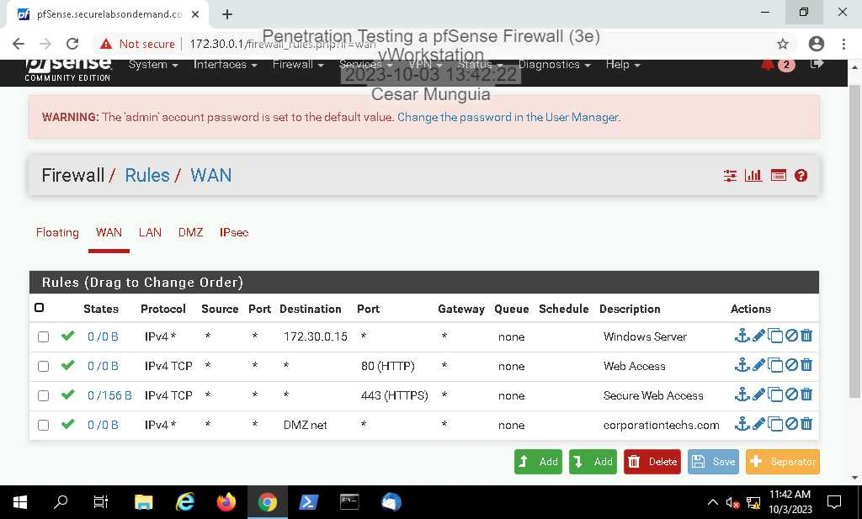

### Part 2: Conduct a Penetration Test on the Network

1. On the Lab View toolbar, I **selected RemoteWindows01** from the Virtual Machine menu to connect to the RemoteWindows01 system.
2. From the RemoteWindows01 taskbar, I **clicked**the**Windows Start button**and**selected Tenable Network Security > Nessus Web Client**from the menu.
3. At the Nessus login screen, I **typed** the following credentials [Username: Administrator; Password: P@ssw0rd!] and **clicked Sign In**to continue.
4. When I was greeted by the Welcome to Nessus Essentials prompt, I **clicked Close**.
5. On the My Scans screen, I **clicked**the **New Scan**button to initiate a new vulnerability scan.
6. On the Scan Templates screen, I **clicked Basic Network Scan**to configure my scan to use the standard vulnerability scanning template. This template checks for open ports on the target system and then uses the most common vulnerability tests to probe the system for vulnerabilities.
7. In the New Scan / Basic Network Scan form, **type** the following information: Name: ***yourname* pen test**, replacing *yourname* with my own name

Description: **Firewall and TargetWindows02 scan**

Folder: **My Scans**

Targets: **202.20.1.1, 202.20.1.3**

1. **I clicked** the **Save** button to save your new scan.
2. On the My Scans page, I **clicked** the **Launch** **icon (the play button)** to begin the scan.
3. When the scan was complete, I **clicked** the **yourname pen test link** to open the scan results. I was presented with a Dashboard view of my scan, showing the number of vulnerabilities of each type detected on the target system.
4. **I made a screen capture** showing the ***cesar* pen test scan results**.

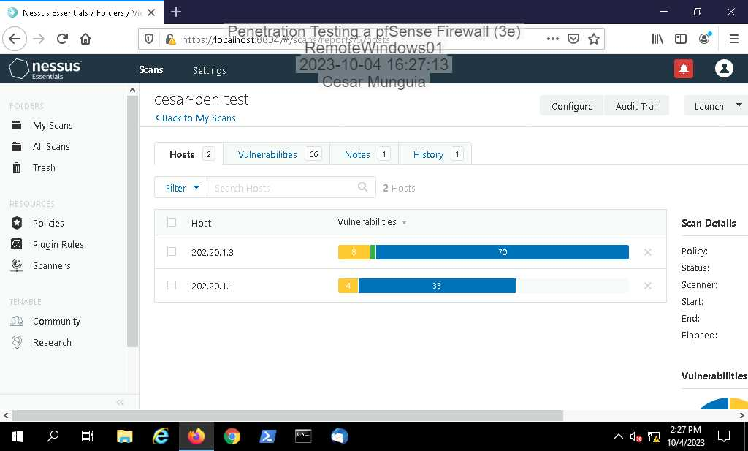

1. From the scan results page,**I clicked** the **Vulnerabilities tab** to view the detailed results of your vulnerability scan.
2. **I made a screen capture**showing the **list of vulnerabilities**.

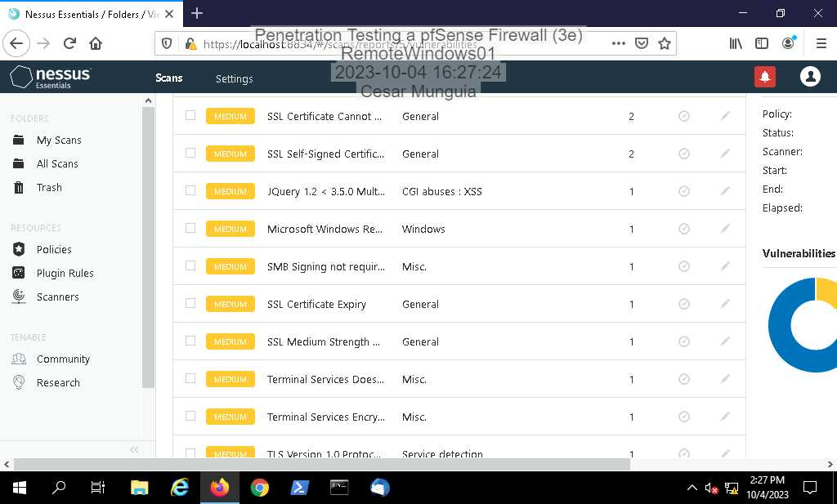

1. On the Vulnerabilities page, I **clicked each Medium severity vulnerability** to review the detailed vulnerability information learn more about the vulnerabilities detected in this scan. The detailed vulnerability information provides a plain-English, high-level description of the problem and a recommendation for the solution.
2. On the Lab View toolbar, I **selected** **vWorkstation** from the Virtual Machine menu to connect to the vWorkstation system and return to the pfSense browser window.
3. On the Firewall / Rules / WAN page, **click** the **trash can icon** to the right of the Windows Server rule to delete this rule. [As I recall, this rule enables traffic from any (*) source using any (*) port to reach the 172.30.0.15 server. Eliminating this rule will result in pfSense blocking all incoming connections on this interface until new pass rules are added. As a defender, my next steps would be to introduce new, more granular pass rules that allow inbound traffic on specific ports to the WAN Rules table. I will not add any new rules to the WAN table in this section.]
4. When prompted, I **clicked OK** to confirm that I wanted to delete this rule.
5. **I repeated step 16-17** for the *Web Access* and *Secure Web Access* rules.
6. On the Firewall / Rules / WAN page, I **clicked** the **Apply Changes button** to apply your changes to the WAN Rules table, then I **clicked**the **LAN** link to open the LAN rules page.
7. On the Firewall / Rules / WAN page, I **clicked**the **LAN** link to open the LAN rules page.
8. On the Firewall / Rules / LAN page, **click** the **trash can icon** to the right of the Default allow LAN to any rule to delete this rule. [Similar to the permissive Windows Server rule on the WAN Rules table, this rule enables any outbound traffic from the LAN to pass through the firewall, and should be eliminated. The remaining pass rules provide a more granular set of guidelines for allowing LAN traffic through the firewall]
9. When prompted, I **clicked OK** to confirm that I wanted to delete this rule.
10. On the Firewall / Rules / LAN page, I **clicked** the **Apply Changes button** to apply my changes to the LAN Rules table.
11. **I closed** the **browser window**.
12. On the Lab View toolbar, I **selected RemoteWindows01** from the Virtual Machine menu to connect to the RemoteWindows01 system.
13. In the Nessus Web Client window, I **click** the **My Scans link** in the Nessus toolbar to return to the My Scans list.
14. On the My Scans page, I **clicked** the **Play button** on the right side of the cesar pen test scan to launch the scan again
15. When the scan is complete,**I clicked**the***cesar* pen test link**to open the scan results.
16. From the scan results page,**I clicked** the **Vulnerabilities link** to list the scanned vulnerabilities. I noticed that the Vulnerabilities list no longer contains any vulnerabilities, confirming that my actions removed the vulnerabilities identified in the first Nessus scan.
17. **I made a screen capture** showing the **updated vulnerability report summary.**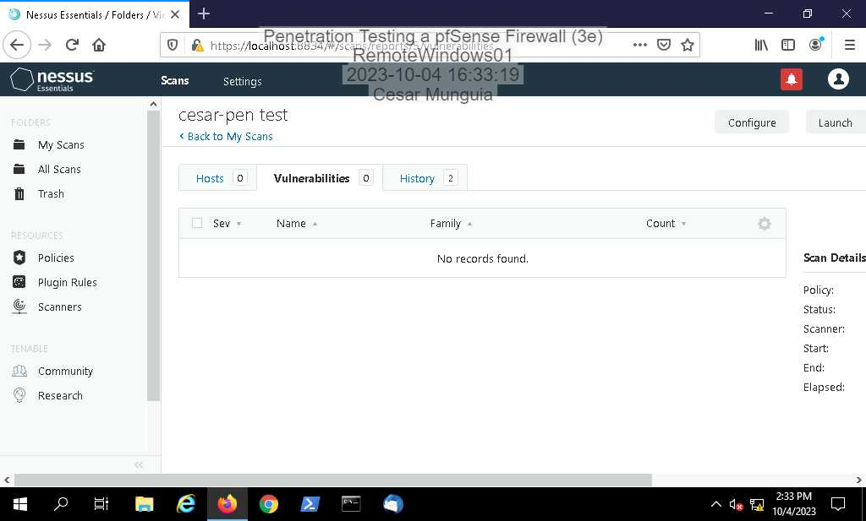
18. **I closed** the **Nessus window**.

# Section 2: Applied Learning

### Part 1: Conduct a Port Scan on the Network

1. From the Virtual Machine menu, I **selected** the **AttackLinux01** system. AttackLinux01 runs Kali Linux, a popular Linux distribution used for penetration testing.
2. At the Kali log-in screen, I used the following credentials [Username: root; Password: toor] to **log in** as the root user.
3. From the AttackLinux01 menu bar, I **clicked** the **Activities menu**, then **clicked**the **Terminal icon** on the Applications bar to open a new Terminal window.
4. At the command prompt, I **executed ping corporationtechs.com** to send a series of ICMP echo requests to the corporationtechs.com domain.
5. After I received a few replies, I **pressed Ctrl-c** to stop the ping.
6. At the command prompt, I **executed traceroute 172.40.0.20** to perform a trace route.
7. **I made a screen capture** showing the **results of the traceroute command**.

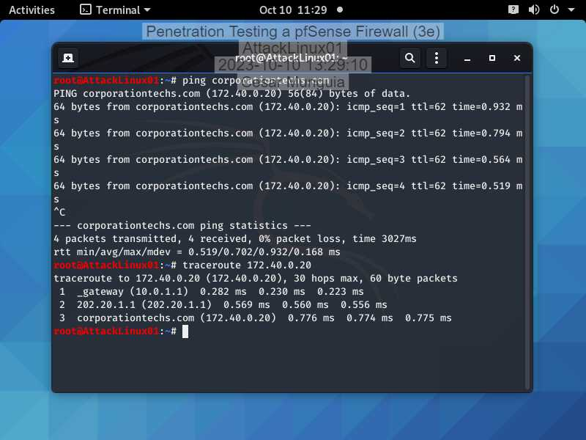

1. At the command prompt, I **executed nmap 202.20.1.1** to conduct a default nmap scan of the target IP address.
2. At the command prompt, I **executed nmap 202.20.1.1/24** to scan for any system with an IP address between 202.20.1.1 and 202.20.1.255.
3. At the command prompt, I **executed nmap -sV -O 202.20.1.3** to scan the second host again with Nmap's Operating System detection feature activated.
4. **I made a screen capture** showing the result of the **nmap scan with OS detection activated**.

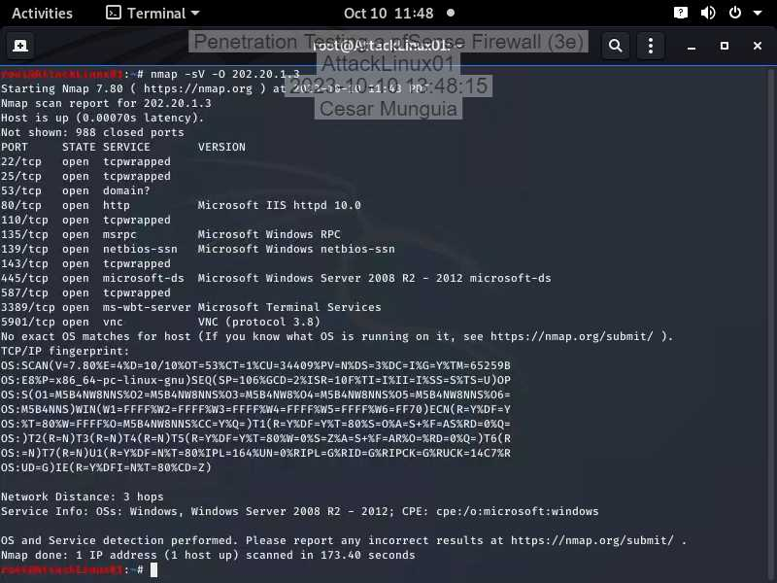

### Part 2: Conduct a Vulnerability Scan on the Network

1. From the Virtual Machine menu, I **selected** the **RemoteWindows01** system
2. **I opened** a new **Firefox window**.
3. **I navigated** to **https://10.0.1.5.**
4. When prompted, I **clicked Advanced**, then **clicked** **Accept the Risk and Continue** to advance to the scanner’s login page.
5. At the Greenbone Security Manager login screen,**I logged in** using the following credentials: [Username: admin; Password: admin].
6. From the Scans menu, I **selected Tasks** to access the Tasks dashboard.
7. **I hovered** over the **New Task**icon (the piece of paper with a star in the upper-left corner), then **selected New Task** from the drop-down menu that appears.
8. **I configured**the new task to conduct a **Full and fast** scan of the TargetWindows02 system (202.20.1.3).
9. **I clicked Save** to save your task.
10. **I clicked the Start icon** to run a vulnerability scan.
11. When the scan was complete, I **clicked** the **1** link under Reports to view the scan report.
12. **I made a screen capture** showing the **OpenVAS scan report**.

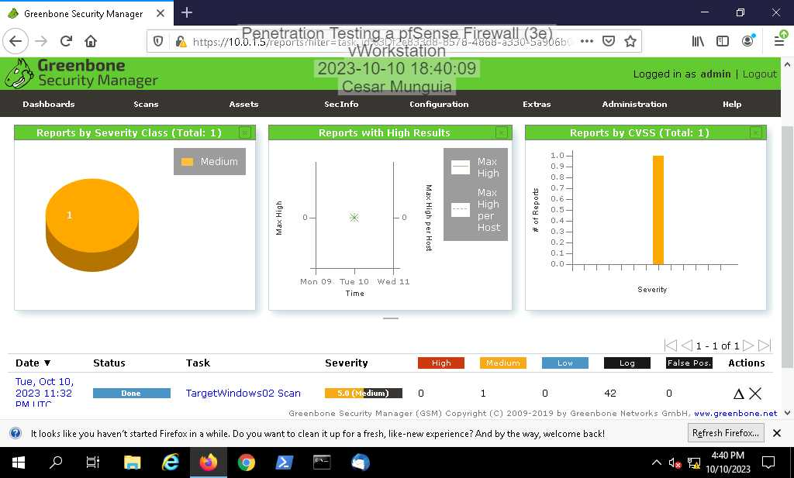

1. From your OpenVAS scan report, I **clicked** **the date and time** to view the detailed results of your vulnerability scan.
2. **I made a screen capture** showing the **detailed OpenVAS scan results**.

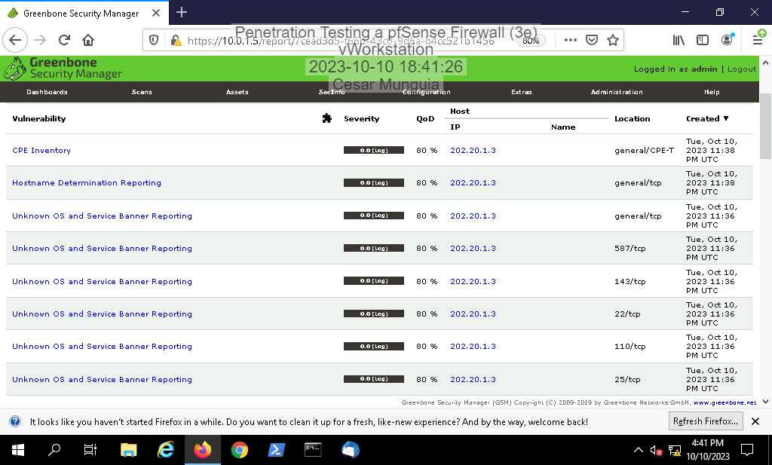

# Section 3: Challenge and Analysis

### Part 1: Research DMZ Deployment Best Practices

Before beginning the technical portion of your penetration test, you decide to spend some time brushing up on best practices and common mistakes for DMZ deployments - both the network aspect and the servers located therein. Use the Internet to **research** DMZ deployments, then **identify** three best practices and one potential mistake or vulnerability.

DMZ networks are meant to protect an internal network with an advanced security layer. This would restrict access to certain data and servers, making them more secure.

The 3 best practices for DMZ are:

* Implementing Zero-Trust Network Access: This is one of the best practices that many big tech companies are implementing because it forces users to authenticate into resources first and then they are granted access. “Allow everything. Trust nothing.”
* Using a Two-Firewall Approach: Two firewalls are better than just one. For that reason, implementing would imply to have the first firewall as the outer perimeter that gets all that “bad” stuff and filter it so that the second firewall (the one in the internal network) does not deal with the bad stuff.
* Making the DMZ a True Discontinuity: This basically means to establish different IP routing and security policies in the DMZ than the internal network. In case a intruder makes his way into the DMZ he could encounter problems trying to access the internal network.

One vulnerability that I found about the DMZ that I think is plain-sight is the fact that it is open to the public. Hackers could utilize scanning tools to find the resources in a company and plan their attacks based on the vulnerabilities that they can find.

### Part 2: Conduct a Penetration Test on the DMZ

As a next step, you will begin the process of pen testing the DMZ.

First, use the AttackLinux01 machine to perform an nmap scan on the corporationtechs.com web server (172.40.0.20) and the DMZ firewall interface (172.40.0.1).

* **Make a screen capture** showing the **open ports on the corporationtechs.com web server and the DMZ firewall interface**.

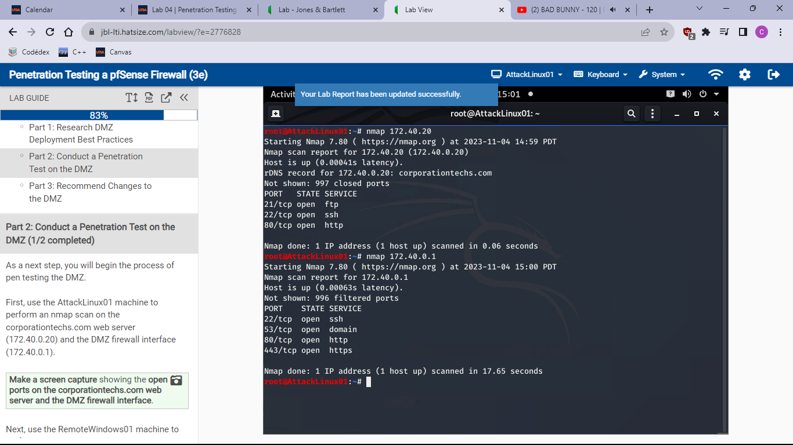

Next, use the RemoteWindows01 machine to perform a Nessus or OpenVAS scan on the corporationtechs.com web server and the DMZ firewall interface.

* **Make a screen capture** showing the **vulnerability scan results**.

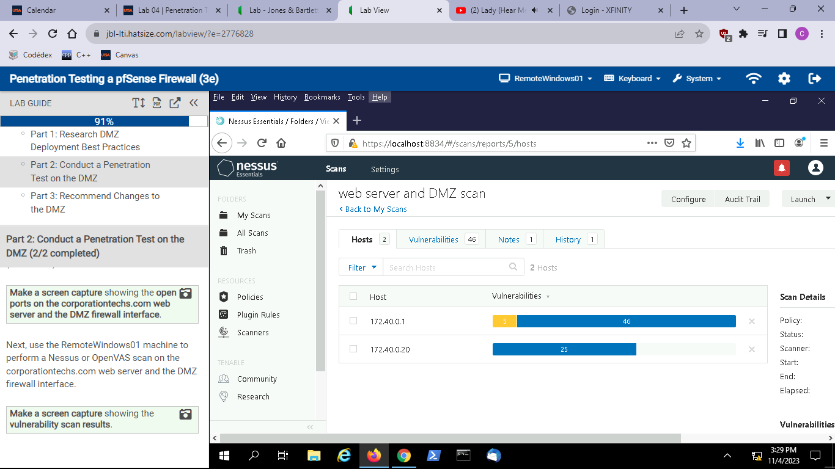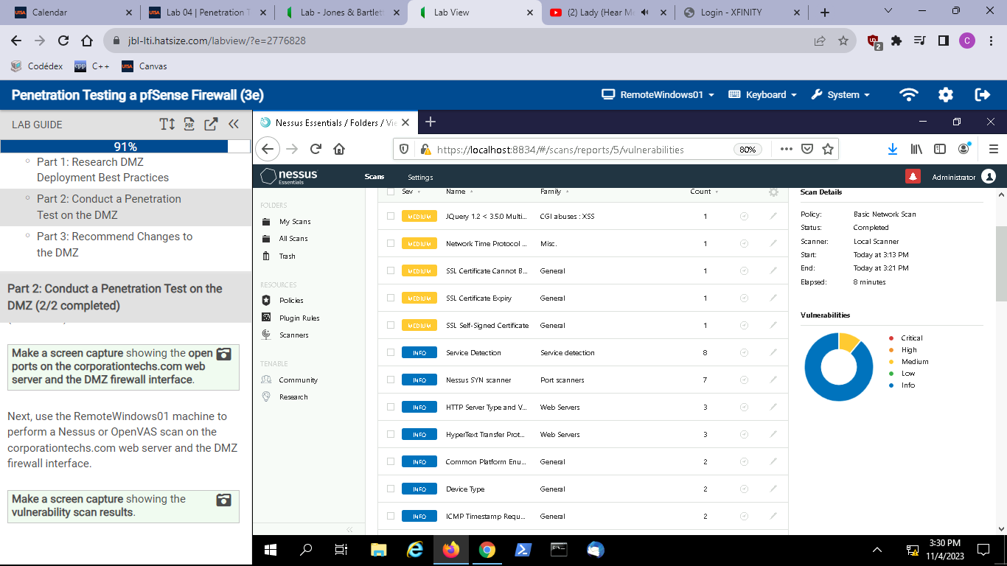

### Part 3: Recommend Changes to the DMZ

Based on your research in Part 1 and your findings in Part 2, **prepare a brief summary** of recommended changes that Secure Labs on Demand should make to their DMZ deployment. Remember, your recommendations should apply to both the network configuration and the web server.

Well, the first thing that I would recommend is to find a way to hide some of the information gathered. What I mean by this is to hide critical information that a hacker might use for his own benefit. Knowing the operating system, services, or any other related information that is running on a server can potentially put the network in danger. So, I would start by minimizing the information available to the external world (Internet) as much as it can.